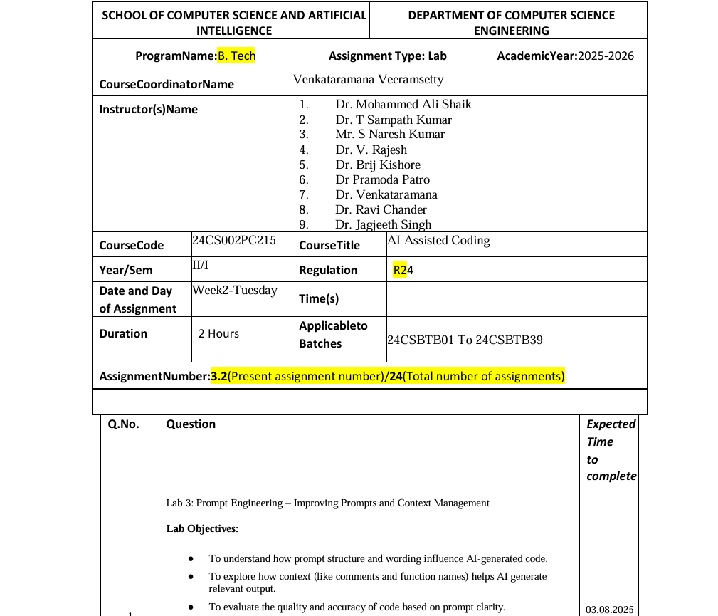

bhc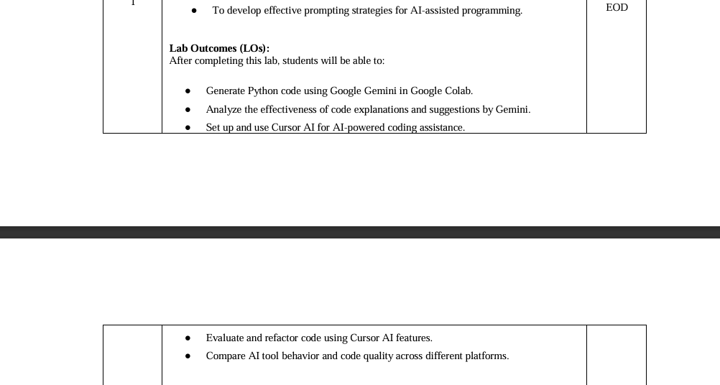

Task Description#1 ● Ask AI to write a function to calculate compound interest, starting with only the function name. Then add a docstring, then input-output example
Expected Output#1 ● Comparison of AI-generated code styles

CODE:
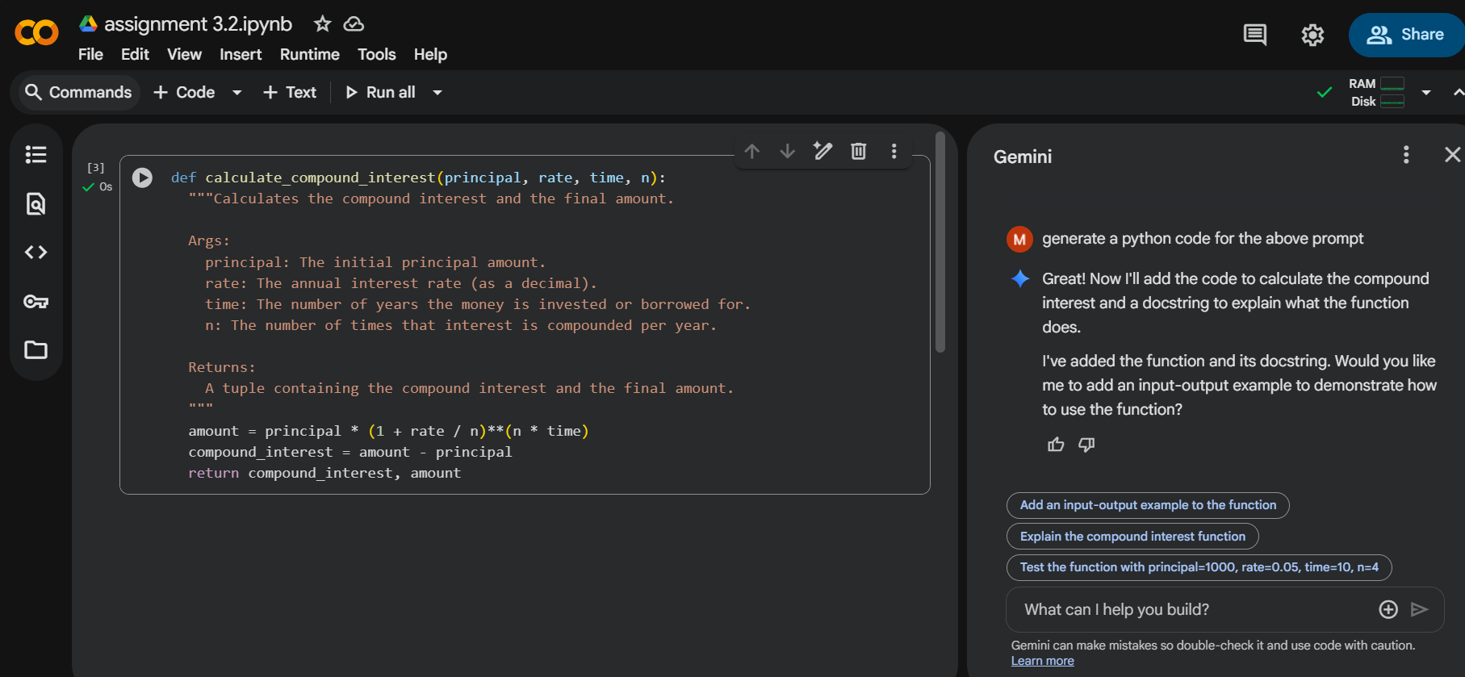
Task Description#2
● Do math stuff, then refine it to: # Write a function to calculate average, median, and
mode of a list of numbers.
Expected Output#2
● AI-generated function evolves from unclear to accurate multi-statistical operation
CODE:
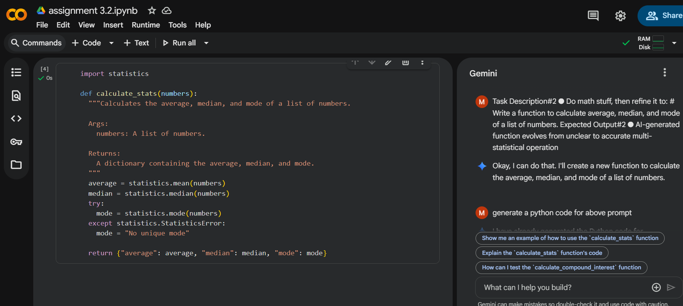

Task Description#3
● Provide multiple examples of input-output to the AI for convert_to_binary(num)
function. Observe how AI uses few-shot prompting to generalize.
Expected Output#3
● Enhanced AI output with clearer prompts
CODE: 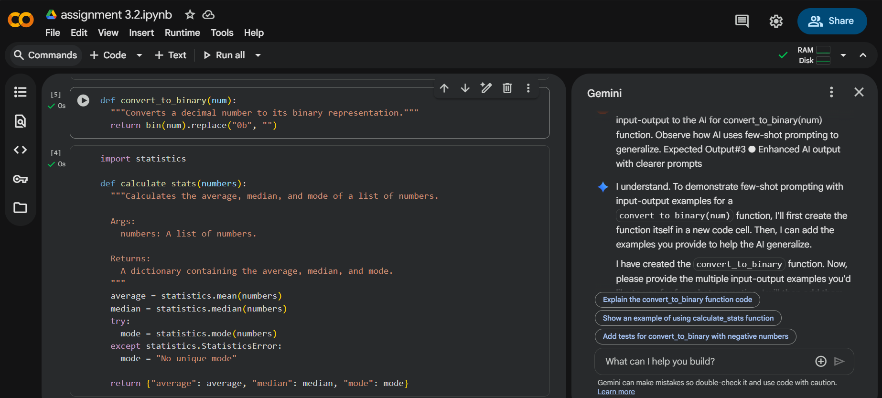
Task Description#4
● Create an user interface for an hotel to generate bill based on customer requirements
Expected Output#4
● Consistent functions with shared logic

CODE: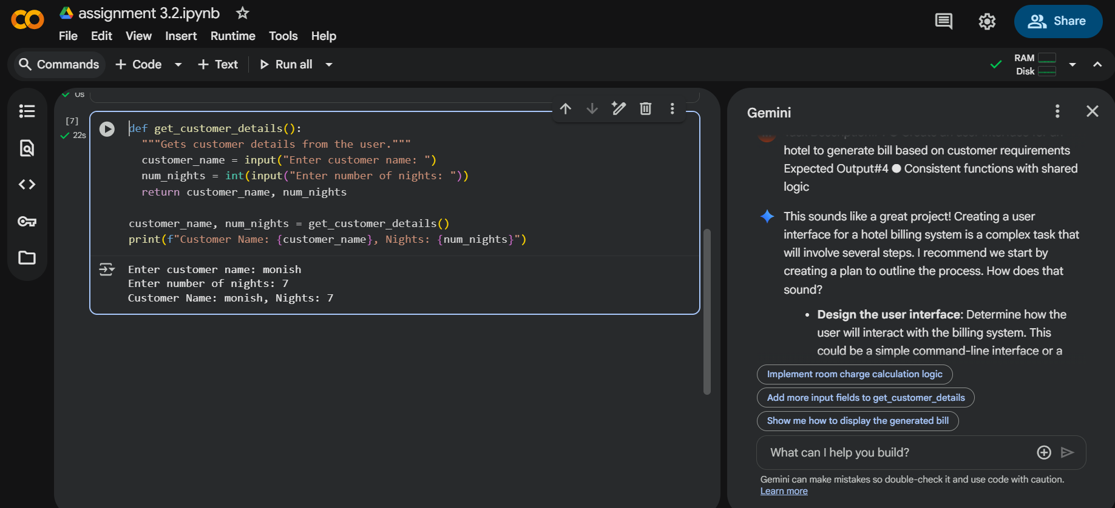

Task Description#5
● Analyzing Prompt Specificity: Improving Temperature Conversion Function with
Clear Instructions
Expected Output#5
● Code quality difference analysis for various prompts
CODE:
